**Title: PawCore Systems Hands-On Lab — From Signals to Decisions with Snowflake Intelligence (90 minutes)**

**Duration**

Total: 90 minutes (hands-on 75–80 minutes, Q&A 10–15 minutes)

**Audience**

Data/AI practitioners, analytics engineers, sales engineers, Snowflake builders

**Objectives**

Tell a cohesive PawCore story: solve "The Mystery of the Missing Revenue" by unifying structured and unstructured data to diagnose regional under-performance, uncover product issues, assess campaign ROI, and automate executive updates with a Snowflake Intelligent Agent.

**Story Setup (What happened?)**

Q4 revenue beat targets overall by 15%, but EMEA region underperformed by 23% for SmartCollar specifically. Leadership is baffled because:

- Marketing spent 40% more on "Holiday Fit for Pets" campaign in EMEA

- Customer satisfaction scores dropped 15% in EMEA during Q4

- Support tickets increased 200% for battery-related issues

- No one can connect the dots between these signals

Our mission: Investigate across structured and unstructured data to solve this mystery, find the root cause, and provide an actionable solution to prevent future revenue losses.

**Assets You Will Use**

**Structured**: pawcore_sales.csv, pet_owners.csv, device_sales_by_region.csv, fitbit_inventory.csv, vet_feedback.csv, email_campaigns.csv, enhanced_sales_data.csv, social_media_posts.csv

**Unstructured**: Q4_2024_PawCore_Financial_Report.md (quarterly dashboard), Sales_Performance_Q4_2024.md (sales report), PawCore Quarterly Call.mp3 (quarterly call), Quarterly_Sales_Speech_PawCore.md (call transcript), pawcore_slack.csv (Slack), customer_reviews.csv (reviews), SmartCollar Product Photo.jpeg (product image), Customer Journey Infographic.pdf (infographic)

**Snowflake**: Role SNOWFLAKE_INTELLIGENCE_ADMIN_RL, Warehouse PAWCORE_INTELLIGENCE_WH, Database PAWCORE_INTELLIGENCE_DEMO with schemas BUSINESS_DATA, DOCUMENTS, AGENTS

**Agenda and Timeboxes**

0–5 min: Story and goals

5–20 min: Environment and data loading

20–35 min: Semantic Views + Cortex Analyst

35–50 min: Document AI (PDFs/images) + Slack + Reviews

50–60 min: Cortex Search Services over unstructured content

60–70 min: Quarterly call insights and cross-signal sentiment

70–80 min: Build the Intelligent Agent and email yourself

80–90 min: Q&A

**Section 1 (0–5 min): Introduce the Story and Target Outcome**

Frame the business questions:

- What caused the 23% SmartCollar revenue shortfall in EMEA?

- Are battery issues mentioned in customer feedback and support data?

- Did the "Holiday Fit for Pets" campaign contribute to or mask the problem?

- Can we automate this type of investigation for future issues?

Outcome: A root-cause narrative and an automated email summary to leadership.

***[SCREENSHOT: Opening slide or document title with objectives]***

**Section 2 (5–20 min): Environment Setup and Data Loading**

**1) Use role, warehouse, and create database/schemas**

USE ROLE ACCOUNTADMIN;

CREATE OR REPLACE WAREHOUSE PAWCORE_INTELLIGENCE_WH WAREHOUSE_SIZE = 'XSMALL' AUTO_SUSPEND = 60 AUTO_RESUME = TRUE;

CREATE OR REPLACE DATABASE PAWCORE_INTELLIGENCE_DEMO;

CREATE OR REPLACE SCHEMA PAWCORE_INTELLIGENCE_DEMO.BUSINESS_DATA;

CREATE OR REPLACE SCHEMA PAWCORE_INTELLIGENCE_DEMO.DOCUMENTS;

CREATE OR REPLACE SCHEMA PAWCORE_INTELLIGENCE_DEMO.AGENTS;

USE DATABASE PAWCORE_INTELLIGENCE_DEMO;

USE SCHEMA BUSINESS_DATA;

USE WAREHOUSE PAWCORE_INTELLIGENCE_WH;

**2) Create file formats and stages**

CREATE OR REPLACE FILE FORMAT CSV_FORMAT TYPE = CSV FIELD_OPTIONALLY_ENCLOSED_BY='"' SKIP_HEADER = 1;

CREATE OR REPLACE FILE FORMAT BINARY_FORMAT TYPE = BINARY;

CREATE OR REPLACE STAGE INTERNAL_DATA_STAGE FILE_FORMAT = CSV_FORMAT;

CREATE OR REPLACE STAGE DOCUMENT_STAGE;

CREATE OR REPLACE STAGE IMAGE_STAGE FILE_FORMAT = BINARY_FORMAT;

CREATE OR REPLACE STAGE AUDIO_STAGE FILE_FORMAT = BINARY_FORMAT;

**3) Upload files to stages (UI: Databases → Stages → Upload)**

- Upload device_sales_by_region.csv, email_campaigns.csv, enhanced_sales_data.csv, fitbit_inventory.csv, pawcore_sales.csv, pet_owners.csv, social_media_posts.csv, vet_feedback.csv to INTERNAL_DATA_STAGE.

- Upload Q4_2024_PawCore_Financial_Report.md, Sales_Performance_Q4_2024.md, Quarterly_Sales_Speech_PawCore.md, pawcore_slack.csv, customer_reviews.csv to DOCUMENT_STAGE:

- Upload SmartCollar Product Photo.jpeg, Customer Journey Infographic.pdf to IMAGE_STAGE.

- Upload PawCore Quarterly Call.mp3 to AUDIO_STAGE.

You can find an organized folder with all Data [here](https://drive.google.com/uc?export=download&id=169wCi9GBsEm81Gx48Sj4t-iAN4fZumAU)

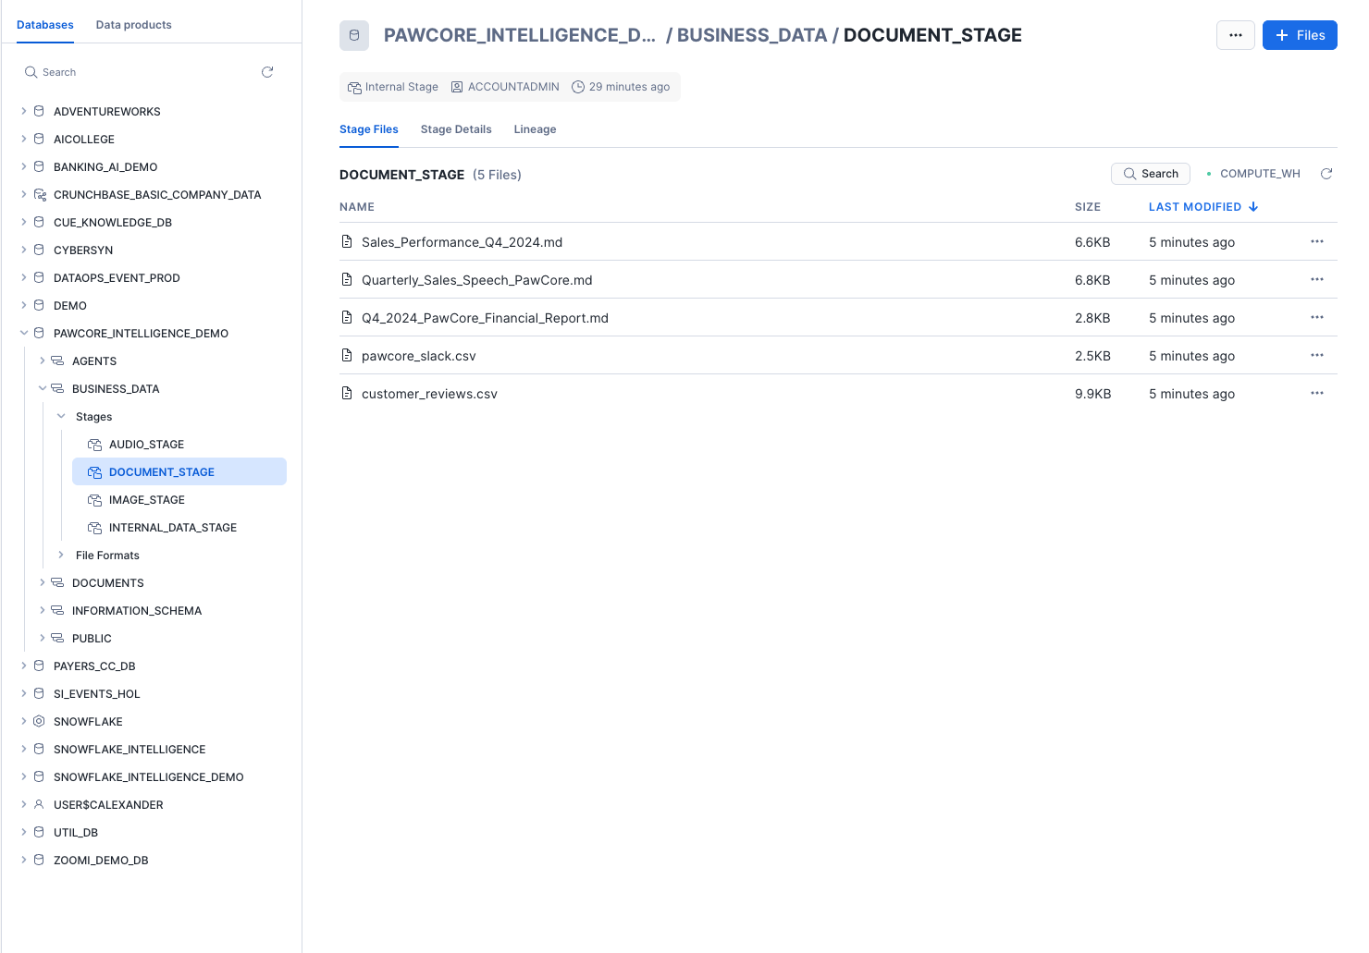

**4) Create core tables and load structured data**

Create tables based on your CSV files:

PAWCORE_SALES (from pawcore_sales.csv)

PET_OWNERS (from pet_owners.csv)

DEVICE_SALES_BY_REGION (from device_sales_by_region.csv)

FITBIT_INVENTORY (from fitbit_inventory.csv)

VET_FEEDBACK (from vet_feedback.csv)

EMAIL_CAMPAIGNS (from email_campaigns.csv)

ENHANCED_SALES_DATA (from enhanced_sales_data.csv)

SOCIAL_MEDIA_POSTS (from social_media_posts.csv)

**Load** with COPY INTO from @INTERNAL_DATA_STAGE.

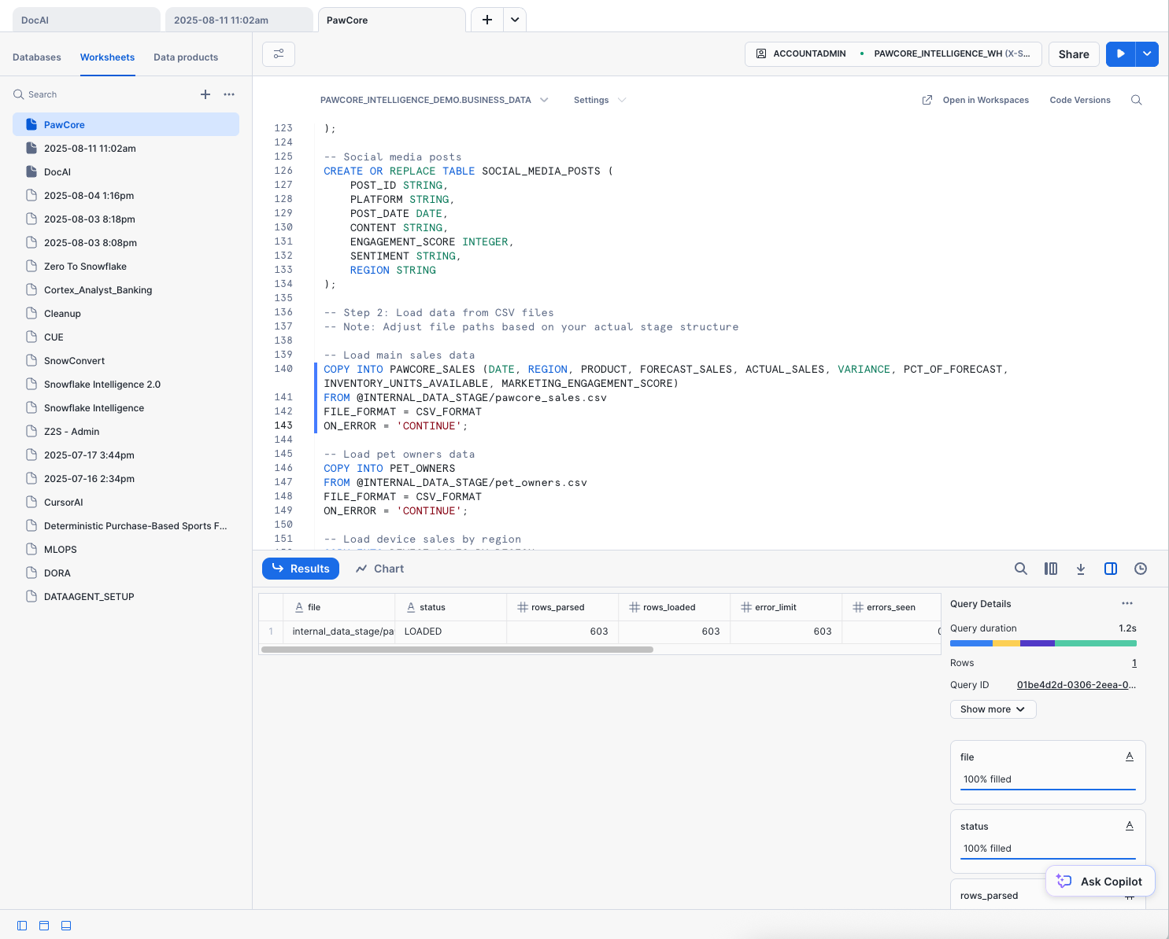

***[SCREENSHOT: Worksheet showing successful COPY row counts]***

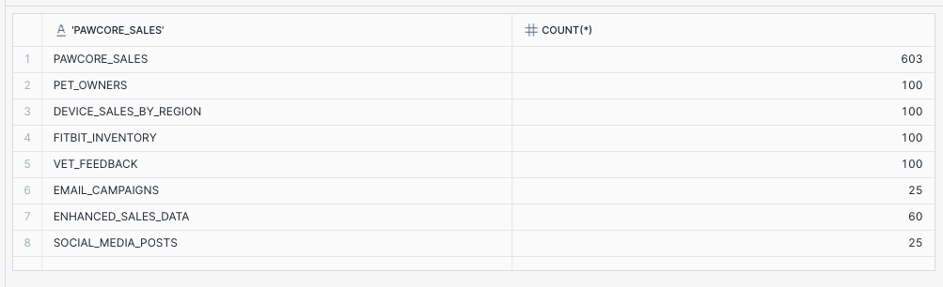

**Section 3 (20–35 min): Semantic Views and Cortex Analyst (Structured Analysis)**

#### 

#### **Navigate to Cortex Analyst**

1. In Snowflake Snowsight, switch to your BANKING_INTELLIGENCE_DEMO role.
2. In the left sidebar, expand **AI & ML** and click **Studio**.
3. Select **Cortex Analyst**.
4. Select **Create new model** option.

**1) Create Sales Semantic View (SQL as backup)**

**Name**: PAWCORE_SALES_SEMANTIC_VIEW

**Tables**: SALES = PAWCORE_SALES (primary key), PET_OWNERS, DEVICE_SALES_BY_REGION, FITBIT_INVENTORY, VET_FEEDBACK, EMAIL_CAMPAIGNS, ENHANCED_SALES_DATA, SOCIAL_MEDIA_POSTS

Add synonyms, descriptions, and relationships as appropriate.

***[SCREENSHOT: Semantic View builder with tables and relationships]***

**2) Create Cortex Analyst Service**

Name: Analyst_PawCore_Sales_Performance

Semantic View: PAWCORE_SALES_SEMANTIC_VIEW

Warehouse: PAWCORE_INTELLIGENCE_WH

***[SCREENSHOT: Analyst service creation confirmation]***

**3) Ask questions in natural language (Cortex Analyst UI)**

“Show Q4 2024 sales by region and product with forecast vs actual and variance. Include a grouped bar chart.”

“Which regions under-performed forecast for SmartCollar and by how much?”

“What inventory or engagement factors correlate with the variance?”

***[SCREENSHOT: Analyst result table and chart]***

Insight checkpoint: Note the variance for SmartCollar in EMEA and any engagement/inventory signals.

**Section 4 (35–50 min): Document AI + Slack + Reviews (Unstructured Cues)**

**1) Process PDFs and images with Document AI (UI)**

Project A: "PawCore Analyst Reports" → ingest Q4_2024_PawCore_Financial_Report.md and Sales_Performance_Q4_2024.md; extract text, tables, KPIs.

Project B: "PawCore Infographics" → ingest SmartCollar Product Photo.jpeg and Customer Journey Infographic.pdf; extract numeric metrics and captions.

***[SCREENSHOT: Document AI extraction previews and fields]***

**2) Materialize parsed content for search and queries (DOCUMENTS schema)**

Create or use a table DOCUMENTS.PARSED_CONTENT with columns: relative_path, file_url (or presigned URL), title, content (extracted text).

Load Slack CSV into DOCUMENTS.SLACK_MESSAGES (columns such as channel, timestamp, message_text, author).

Load customer reviews CSV into DOCUMENTS.CUSTOMER_REVIEWS (rating, product, review_text, date).

***[SCREENSHOT: Sample rows from PARSED_CONTENT, SLACK_MESSAGES, CUSTOMER_REVIEWS]***

**3) Quick checks**

SELECT COUNT(*) from each table; spot check content for SmartCollar battery mentions and campaign results.

***[SCREENSHOT: Counts and a sample SELECT with highlighted text]***

**Section 5 (50–60 min): Cortex Search Services (Following the Evidence Trail)**

**1) Create focused search services**

Search_PawCore_Finance_Docs on DOCUMENTS.PARSED_CONTENT filtered to finance/review documents.

Search_PawCore_Product_Docs on DOCUMENTS.PARSED_CONTENT filtered to SmartCollar/product topics.

Search_PawCore_Operations_Docs union of PARSED_CONTENT + SLACK_MESSAGES + CUSTOMER_REVIEWS for broad ops sentiment.

***[SCREENSHOT: SHOW CORTEX SEARCH SERVICES and a sample search query in UI]***

**2) Ask targeted questions**

"Summarize key Q4 drivers and risks mentioned in the quarterly review."

"Find all mentions of battery performance issues for SmartCollar across documents, Slack, and reviews."

"Are there references to returns/refunds related to SmartCollar?"

***[SCREENSHOT: Search result snippets highlighting relevant passages]***

**Section 6 (60–70 min): Quarterly Call Insights and Cross-Signal Sentiment (Connecting the Dots)**

1) Load the quarterly call transcript into DOCUMENTS.CALL_TRANSCRIPT(TEXT) from Quarterly_Sales_Speech_PawCore.md.

2) Create a unified view for sentiment and mention counts

CUSTOMER_SIGNAL_FEED as union of Slack message_text, review_text, and call transcript text.

Compute average sentiment by source using SNOWFLAKE.CORTEX.SENTIMENT.

***[SCREENSHOT: Sentiment by source results and a simple bar chart (Worksheet or Streamlit)]***

Investigation checkpoint: Look for correlation between EMEA variance and SmartCollar battery sentiment trend. Note if campaign references appear positive or neutral.

**Section 7 (70–80 min): Build the Intelligent Agent and Solve the Mystery**

**1) Email integration and procedure (AGENTS schema)**

Create NOTIFICATION INTEGRATION PAWCORE_EMAIL_INT (TYPE = EMAIL, ENABLED = TRUE).

Create procedure AGENTS.SEND_MAIL(recipient, subject, content) in Python that calls SYSTEM$SEND_EMAIL with HTML content.

***[SCREENSHOT: Procedure successfully created]***

**2) Create the Agent with tools**

Name: PAWCORE_BI_AGENT

Instructions: You are a revenue detective. Analyze structured data via Semantic Views; search unstructured content via Cortex Search; synthesize insights; create charts where useful; avoid citation markers; deliver concise executive summaries with recommendations. Focus on solving the EMEA SmartCollar revenue mystery.

Tools:

- cortex_analyst_text_to_sql → Analyst_PawCore_Sales_Performance

- cortex_search → Search_PawCore_Product_Docs, Search_PawCore_Finance_Docs, Search_PawCore_Operations_Docs

- procedure → AGENTS.SEND_MAIL

***[SCREENSHOT: Agent configuration summary showing tools enabled]***

**3) Run the end-to-end prompt**

"Solve the mystery of the missing EMEA SmartCollar revenue. Analyze performance by region in Q4 2024, correlate to customer sentiment and documented issues, and recommend top 3 actions. Include a chart comparing forecast vs actual by region. Then email the executive summary to me at caleb.alexander@snowflake.com."

***[SCREENSHOT: Agent response showing chart and a confirmation that email was sent]***

**4) Verify the email**

Check inbox for subject "PawCore Q4 Findings — SmartCollar Performance and Actions".

Confirm summary includes EMEA under-performance, battery theme evidence, campaign ROI outcome, and three prioritized actions (e.g., firmware update rollout, targeted EMEA support playbook, campaign optimization).

***[SCREENSHOT: Email in inbox (redacted)]***

**Section 8 (80–90 min): Q&A and Extensions**

Variations: add financial gross margin analysis; attribute campaign lift; product lifecycle trends; support ticket topics.

Troubleshooting:

- Services "INITIALIZING": wait and ensure PAWCORE_INTELLIGENCE_WH is running.

- No results: verify data loaded and search scopes; check permissions on schemas/stages.

- Charts missing: explicitly ask "include a bar chart," or visualize in Worksheet/Streamlit.

Appendix: Quick Reference (copy/paste)

Prompts to try

Analyst: "Quarter-over-quarter change in SmartCollar revenue and variance by region with a grouped bar chart."

Search: "Summarize all mentions of battery performance issues in 3 bullet points."

Agent: "Create a one-page executive briefing combining KPIs and customer voice and email it to me."

**Key objects**

Warehouse: PAWCORE_INTELLIGENCE_WH

Database/Schemas: PAWCORE_INTELLIGENCE_DEMO (BUSINESS_DATA, DOCUMENTS, AGENTS)

Semantic View: PAWCORE_SALES_SEMANTIC_VIEW

Analyst Service: Analyst_PawCore_Sales_Performance

Search Services: Search_PawCore_Finance_Docs, Search_PawCore_Product_Docs, Search_PawCore_Operations_Docs

Email Integration: PAWCORE_EMAIL_INT

Procedure: AGENTS.SEND_MAIL

Agent: PAWCORE_BI_AGENT

File names (replace with your exact paths)

**Structured**: pawcore_sales.csv, pet_owners.csv, device_sales_by_region.csv, fitbit_inventory.csv, vet_feedback.csv, email_campaigns.csv, enhanced_sales_data.csv, social_media_posts.csv

**Unstructured**: Q4_2024_PawCore_Financial_Report.md, Sales_Performance_Q4_2024.md, PawCore Quarterly Call.mp3, Quarterly_Sales_Speech_PawCore.md, pawcore_slack.csv, customer_reviews.csv, SmartCollar Product Photo.jpeg, Customer Journey Infographic.pdf

**Next Steps to Finalize**

Confirm your exact file names/paths if different from the samples above.

If the call MP3 has no transcript, decide whether to use a pre-transcribed text or skip that portion.